Sahithi goud

**Sql project**

**Create a Database Schema and Table Relationships for a Logistic Company's Data**

**ABSTRACT**

Logistics is the support function of an organization and it means having the right object, at the right place, in the right time. Logistics deals with various kinds of methods to control the flow of resources from one place to another. One of the major and the most important factors that is costing is being dealt with utmost attention. The project is being designed keeping in mind the details of the various requirements of logistics such as keeping records of the goods; i.e. their details and the kind of content that is stored in the shipment which is to be delivered. A Relational Database Management System (RDBMS) is similar to DBMS. The difference is that in RDBMS, the entities and values in tables are related to one another. Also the tables are related to each other. Thus, it is called “Relational”.

**PROBLEM DESCRIPTION**

The logistics company provides services in both the international and domestic sectors. The logistics management takes into consideration every facility that has an impact on cost. It plays an important role in making the product confirm to customer requirements. Also, it involves efficient integration of suppliers, manufacturers, Import & export and other activities at many levels; from the strategic level through the tactical to the operational level. Customers can send different types of shipping contents. Payment is to be done at the same time the product is delivered to the client. Delivery boy and centre head can update the status of the shipment. Create a database schema and table relationships that can be used in any technology.

**SCOPE**

It is of critical importance to the organization how it delivers products & services to the customer, whether the product is tangible or intangible. Effective and efficient physical movement of the tangible product will speak of intangible services associated with the product and the organization which is delivering it. In case of intangible products, the delivery of tangibles at the right place & right time will speak about its quality. On the macro level infrastructure such as various modes of transport, transportation equipment, storage facilities, connectivity and information processing are contributing to a large extent in the physical movement of goods produced in manufacturing, mining and agriculture Sectors.

**CREATION OF SCHEMA**

CREATE SCHEMA LOGISTICS;

**TABLE DEFINATIONS**

CUSTOMER,

EMPLOYEE_DETAILS,

SHIPPMENT_DETAILS,

PAYMENT_DETAILS,

MEMBERDHIP,

STATUS,

EMPLOYEE_MANAGES_SHIPMENT;

TABLE CUSTOMER

Cust_ID INT NOT NULL,

Membership_M_ID INT NOT NULL,

Cust_name VARCHAR(30) NULL,

Cust_email_id VARCHAR(50) NULL,

Cust_type VARCHAR(20) NULL,

Cust_addr VARCHAR(100) NULL,

Cust_cont_no VARCHAR (10) NULL,

PRIMARY KEY (Cust_ID, Membership_M_ID)

);

TABLE EMPLOYEE_DETAILS

Emp_ID INT NOT NULL,

Emp_name VARCHAR(30) NULL,

Emp_designation VARCHAR(40) NULL,

Emp_addr VARCHAR(100) NULL,

Emp_branch VARCHAR(30) NULL,

Emp_Cont_no float NULL,

PRIMARY KEY (Emp_id)

);

TABLE SHIPPMENT_DETAILS

Sd_id VARCHAR(6) NOT NULL,

Customer_Cust_ID INT NOT NULL,

Sd_content VARCHAR(40) NULL,

Sd_domain VARCHAR(15) NULL,

Sd_type VARCHAR(15) NULL,

Sd_weight VARCHAR(10) NULL,

Sd_charges INT NULL,

Sd_addr VARCHAR(100) NULL,

Ds_Addr VARCHAR(100) NULL,

PRIMARY KEY (Sd_id, Customer_Cust_ID)

);

TABLE PAYMENT_DETAIL

PAYMENT_ID VARCHAR(40) NOT NULL,

Shipment_Details_Customer_Cust_ID INT NOT NULL,

Shipment_Details_Sd_id VARCHAR(6) NOT NULL,

Amount INT NULL,

Payment_Status VARCHAR(10) NULL,

Payment_Mode VARCHAR(25) NULL,

Payment_Date TEXT NULL,

PRIMARY KEY (PAYMENT_ID, Shipment_Details_Sd_id, Shipment_Details_Customer_Cust_ID)

);

TABLE MEMBERSHIP

CREATE TABLE Membership(

M_ID INT NOT NULL,

Start_Date TEXT NULL,

End_Date TEXT NULL,

PRIMARY KEY (M_ID)

);

TABLE EMPLOYEE_MANAGES_SHIPMENTS

CREATE TABLE Employee_Manages_Shipment(

Employee_E_ID INT NOT NULL,

Shipment_Sh_id VARCHAR(6) NOT NULL,

Status_Sh_id VARCHAR(6) NOT NULL,

PRIMARY KEY (Employee_E_ID,Shipment_Sh_id, Status_Sh_id)

);

**QUERYS**

CREATE TABLE Customer(

Cust_ID INT NOT NULL,

Membership_M_ID INT NOT NULL,

Cust_name VARCHAR(30) NULL,

Cust_email_id VARCHAR(50) NULL,

Cust_type VARCHAR(20) NULL,

Cust_addr VARCHAR(100) NULL,

Cust_cont_no VARCHAR (10) NULL,

PRIMARY KEY (Cust_ID, Membership_M_ID)

);

SELECT * FROM Customer;

BULK INSERT Customer

FROM 'C:\Users\Santhosh\Desktop\customer.csv'

WITH (FIRSTROW = 2,

FIELDTERMINATOR = ',',

ROWTERMINATOR = '\n');

SELECT * FROM Customer;

CREATE TABLE Employee_Details(

Emp_ID INT NOT NULL,

Emp_name VARCHAR(30) NULL,

Emp_designation VARCHAR(40) NULL,

Emp_addr VARCHAR(100) NULL,

Emp_branch VARCHAR(30) NULL,

Emp_Cont_no float NULL,

PRIMARY KEY (Emp_ID)

);

BULK INSERT Employee_Details

FROM 'C:\Users\Santhosh\Downloads\employee details.csv'

WITH (FIRSTROW = 2,

FIELDTERMINATOR = ',',

ROWTERMINATOR = '\n');

select * from Employee_Details;

CREATE TABLE Shipment_Details(

Sd_id VARCHAR(6) NOT NULL,

Customer_Cust_ID INT NOT NULL,

Sd_content VARCHAR(40) NULL,

Sd_domain VARCHAR(15) NULL,

Sd_type VARCHAR(15) NULL,

Sd_weight VARCHAR(10) NULL,

Sd_charges INT NULL,

Sd_addr VARCHAR(100) NULL,

Ds_Addr VARCHAR(100) NULL,

PRIMARY KEY (Sd_id, Customer_Cust_ID)

);

BULK INSERT Shipment_details

FROM 'C:\Users\Santhosh\Downloads\shippment details.csv'

WITH (FIRSTROW = 2,

FIELDTERMINATOR = ',',

ROWTERMINATOR = '\n');

select * from Shipment_Details;

CREATE TABLE Payment_Details(

PAYMENT_ID VARCHAR(40) NOT NULL,

Shipment_Details_Customer_Cust_ID INT NOT NULL,

Shipment_Details_Sd_id VARCHAR(6) NOT NULL,

Amount INT NULL,

Payment_Status VARCHAR(10) NULL,

Payment_Mode VARCHAR(25) NULL,

Payment_Date TEXT NULL,

PRIMARY KEY (PAYMENT_ID, Shipment_Details_Sd_id, Shipment_Details_Customer_Cust_ID)

);

BULK INSERT Payment_Details

FROM 'C:\Users\Santhosh\Downloads\payment details.csv'

WITH (FIRSTROW =2,

FIELDTERMINATOR = ',',

ROWTERMINATOR = '\n');

select * from Payment_Details;

CREATE TABLE Membership(

M_ID INT NOT NULL,

Start_Date TEXT NULL,

End_Date TEXT NULL,

PRIMARY KEY (M_ID)

);

bulk insert membership

from 'C:\Users\Santhosh\Downloads\membership (1).csv'

with (firstrow = 2,

fieldterminator = ',',

rowterminator = '\n');

select * form membership;

CREATE TABLE Status(

Sh_id VARCHAR(6) NOT NULL,

Current_ST VARCHAR(15) NOT NULL,

Sent_date TEXT NULL,

Delivery_date TEXT NULL,

PRIMARY KEY (Sh_id)

);

BULK INSERT Status

FROM 'C:\Users\Santhosh\Downloads\status.csv'

WITH (FIRSTROW = 2,

FIELDTERMINATOR = ',',

ROWTERMINATOR = '\n');

select * from Status;

CREATE TABLE Employee_Manages_Shipment(

Employee_E_ID INT NOT NULL,

Shipment_Sh_id VARCHAR(6) NOT NULL,

Status_Sh_id VARCHAR(6) NOT NULL,

PRIMARY KEY (Employee_E_ID,Shipment_Sh_id, Status_Sh_id)

);

BULK INSERT Employee_Manages_Shipment

FROM 'C:\Users\Santhosh\Downloads\employee manage shipment.csv'

WITH (FIRSTROW = 2,

FIELDTERMINATOR =',',

ROWTERMINATOR ='\n');

select * from Employee_Manages_Shipment;

**OUTPUTS**

TABLE CUSTOMERS

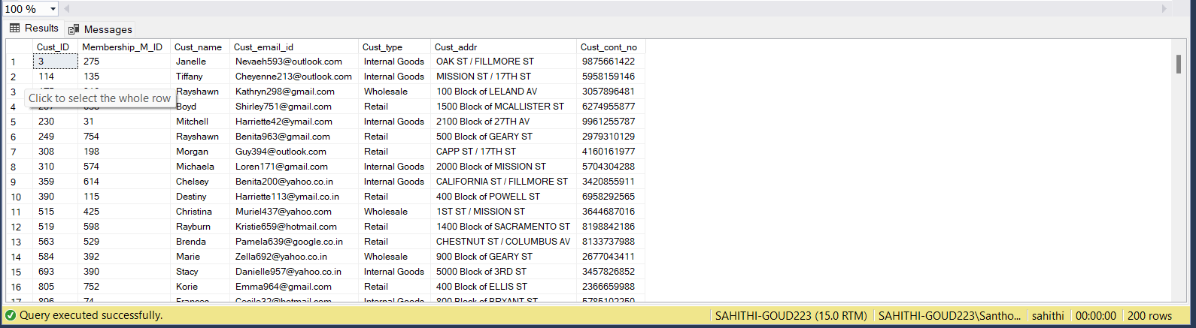

TABLE EMPLOYEE_DETAILS

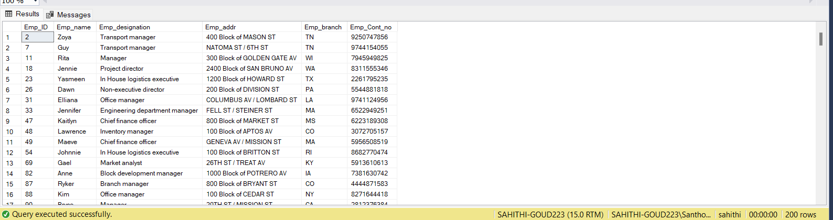

TABLE SHIPMENT DETAILS

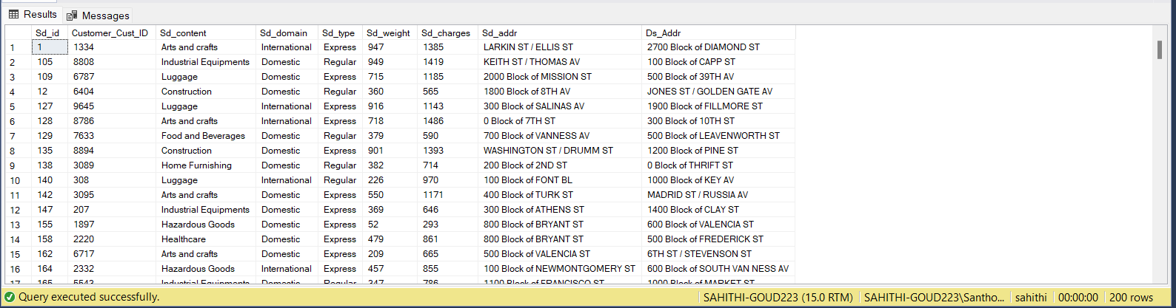

TABLE PAYMENT DETAILS

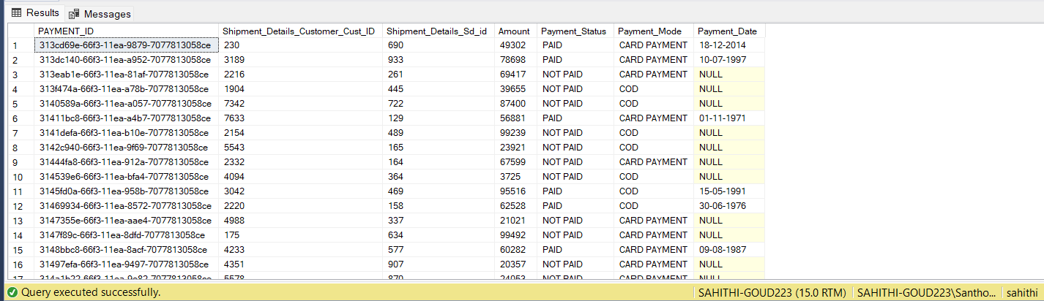

TABLE MEMBERSHIP

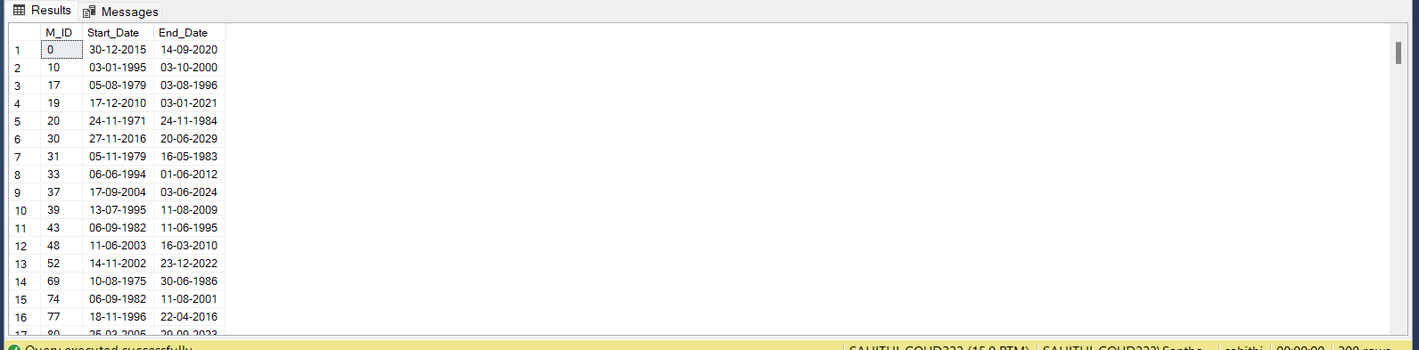

TABLE STATUS

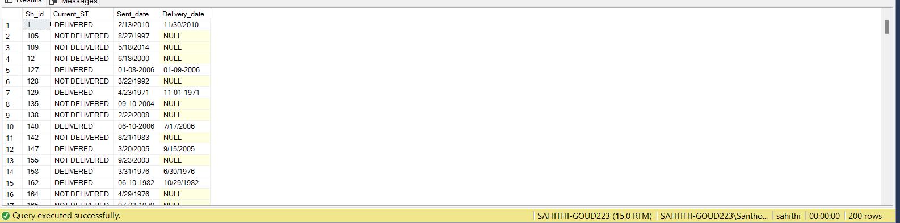

TABLE EMPLOYEE_MANAGES_DETAILS

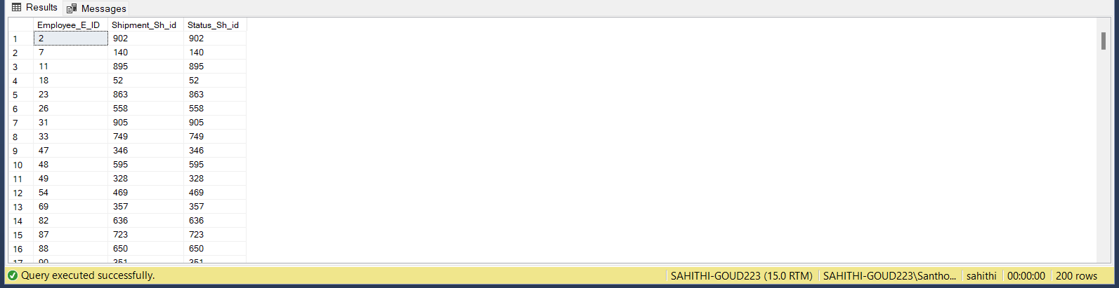

**CONCLUSION**

Logistics systems and transportation consist of interdependent relationships that logistics management requires transportation to perform its day to day activities and meanwhile, a good logistics system can efficiently improve transportation development and traffic environment.

Logistics management is essential to the supply chain of a business. It ensures cost-effective measures and helps achieve the highest degree of customer satisfaction.